**Format to report your ADVANCED JAVA PROGRAMMING PROJECTS**

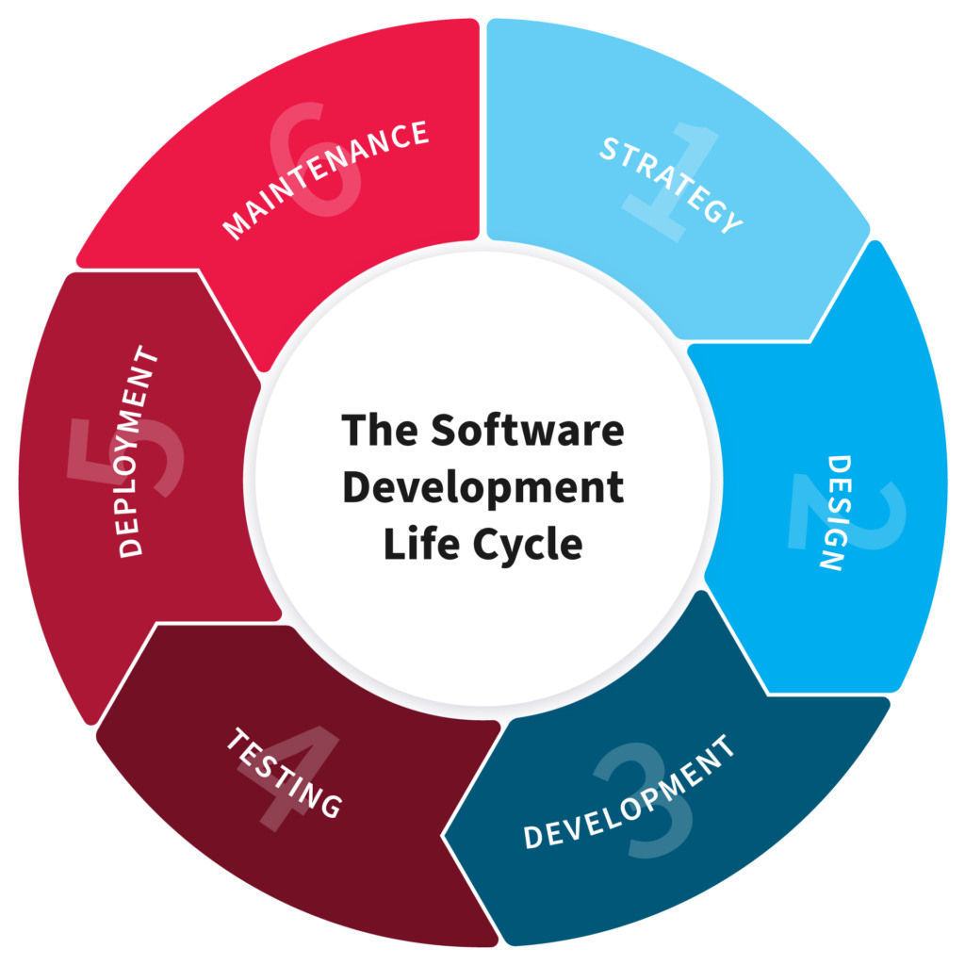

**NB:** EVERY STUDENTS HAS TO PRODUCE THIS DOC

**NAME:** NDATIMANA Jean Marie Vianney

**REG NO:** 221004084

**CLASS NO:** 72

**PROJECT NAME: Computer Based Census Management System**

1. **PLANNING**

**Define:** Computer based cencus management system is a system that will have all information about human population and retrieving of data when ever needed in the society. It focuses on the registration, retrieval and management of information about individuals in the society.

**Goals and objectives:**

* To develop computerized software that automatically stores and retrieves all information on human population.
* To develop a reliable system that could be used in collecting data/information on human population.
* To develop a system that will support direct access to the specific and required information.

**Problems our system can solve:** The system will solve problem associated with the acquisition, storage, and retrieval of information on human population with ease.

**2. Design**

System work:It focuses on the registration, retrieval and management of information about individuals in the society. And population or the user can participate for our system in requesting same information about him/her. Before to acces the information about our system you may login first if you are admin get admin page else user go to page of registration and other menu.

**3. Development**

In the development stage we was using java programming language and MYSQL Database. We used Apache NetBeans as compule . so we using the mysql connector to connect our system and the database that help us to acces the the information stored in the database, we was using sql language.

**4. Testing**

on this part of assessing whether the system works well, we have introduced people to the system and get out of it is very popular and efficient. and that we have requesting for information on the system to come in handy.

**5. Deployment**

in this stage, you use our primary system and include a confidential number that will end our system and check if it has registered in our repository and will end up giving him the right to log in after assessing whether he is not lying. another our system would use it whenever you have a driver either on a telephone or on a computer.